ST. XAVIER’S COLLEGE

**(Affiliated to Tribhuvan University)**

Maitighar, Kathmandu



**Database Management System**

**Assignment #6**

**SUBMITTED BY:**

Divya Jyoti Pokharel

013BSCCSIT019

**SUBMITTED TO:**

|  |  |
| --- | --- |
| **Er. Sanjay Kumar Yadav**  Lecturer  St. Xavier’s College |  |

**Date of Submission:** September 9, 2015

Join

Join is a combination of a Cartesian product followed by a selection process. A Join operation pairs two tuples from different relations, if and only if a given join condition is satisfied.

An SQL JOIN clause is used to combine rows from two or more tables, based on a common field between them.

* Theta join

Theta join combines tuples from different relations provided they satisfy the theta condition. The join condition is denoted by the symbol θ.

* Natural Join
  + Right Join

The RIGHT JOIN keyword returns all rows from the right table (table2), with the matching rows in the left table (table1). The result is NULL in the left side when there is no match.

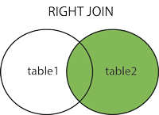

The RIGHT JOIN keyword returns all the rows from the right table (Employees), even if there are no matches in the left table (Orders)

* + Left Join

The LEFT JOIN keyword returns all rows from the left table (table1), with the matching rows in the right table (table2). The result is NULL in the right side when there is no match.

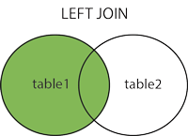

The LEFT JOIN keyword returns all the rows from the left table (Customers), even if there are no matches in the right table (Orders).

* + Inner Join

The INNER JOIN keyword selects all rows from both tables as long as there is a match between the columns in both tables.

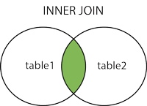

The INNER JOIN keyword selects all rows from both tables as long as there is a match between the columns. If there are rows in the "Customers" table that do not have matches in "Orders", these customers will NOT be listed.

Rename Operation

The results of relational algebra are also relations but without any name. The rename operation allows us to rename the output relation. 'rename' operation is denoted with small Greek letter rho ρ.

Notation − ρ x (E)

Where the result of expression E is saved with name of x.

Example

Transcript ( StudId, CrsCode, Semester, Grade)

Teaching (ProfId, CrsCode, Semester)

πStudId, CrsCode (Transcript) [StudId, CrsCode1] × πProfId, CrsCode (Teaching) [ProfId, CrsCode2]

Assignment Operator

Division Operation

Additional Operations

* Set-intersection Operation
* Natural Join Operation